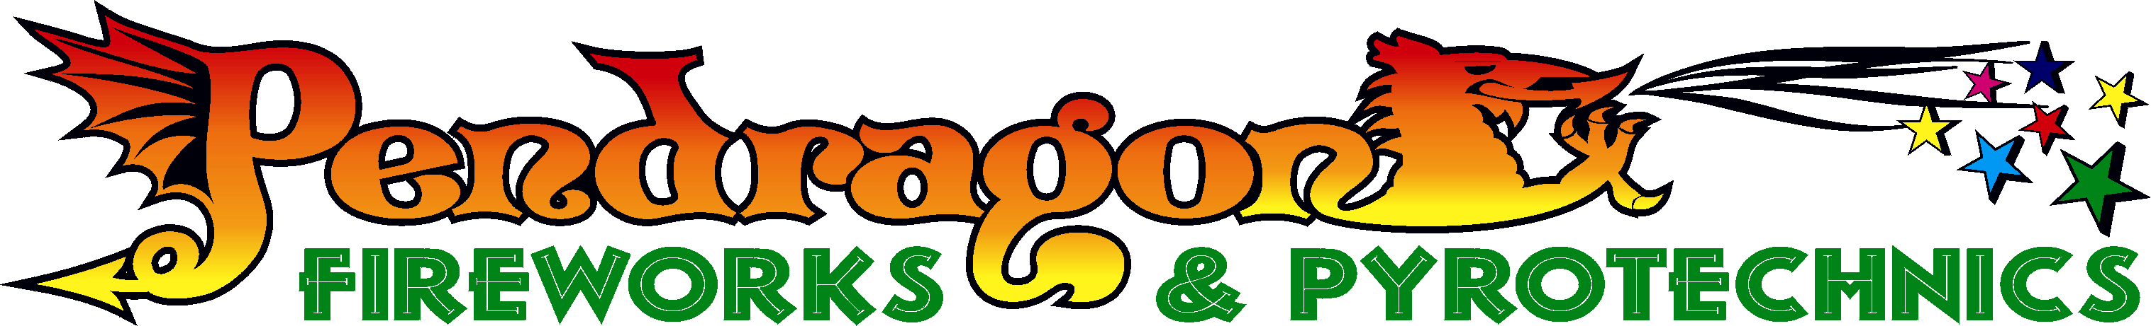
Unit 16 Somerset Rd Ind Est , Cwmbran, Torfaen. NP44 1QX
Tel :- 01633 482626 Fax :- 01633 482929

Press release.

2008 Welsh Firework Champions
2008 British Firework Champions

After many years of hard work, Pendragon fireworks have been successful in winning both the Welsh and British fireworks championships in Plymouth England, using the digital pyromate system and the smart show software.
After many hours of programming and planning, selecting fireworks from around the world. The day started with six hours of heavy rain and strong winds for our crew on the Plymouth breakwater.
A break in the weather, the evening cleared and in front of 100,000 spectators, the second night of displays started with a very good show, firing last our display incorporated a aluminium truss arch which was 30 meters wide and 15 meters high with various effects firing from it. Firing a colour changing sequence and finishing with a red and blue finale we impressed the judges enough to win.
Owner Mr Jonathan Mellen said it was like winning a gold medal at the Olympics for him as he lifted the trophy. The display was then dedicated to Mr Mellen’s father who had been suffering from cancer and passed away three days after the display. 